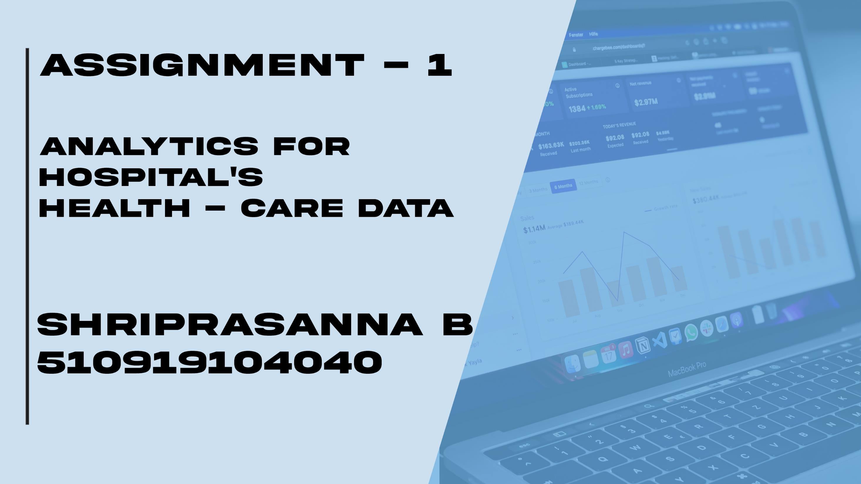

**720719104115**

**NAVEEN KUMAR R**



+

**State**

**and Administration for R&D Spend colored**

**by Marketing**

**Spend**

+

**R&D Spend by State**

+

**Administration and Marketing Spend for R&D Spend colored by State**

+

**Marketing Spend and Administration with State and State for R&D**

**Spend**

+

**Administration by R&D Spend colored by State**

**State and Admin for R&D Spend colored by Marketing Spend**

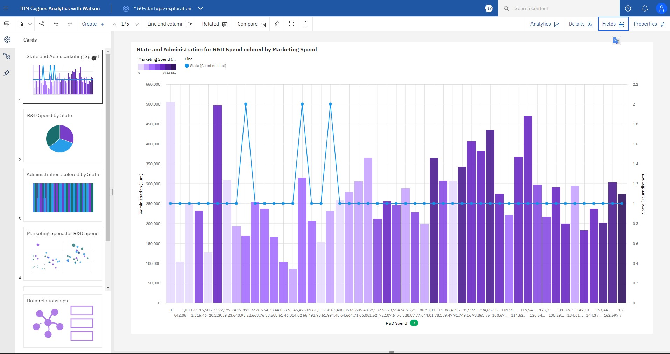

# R&D Spend by State

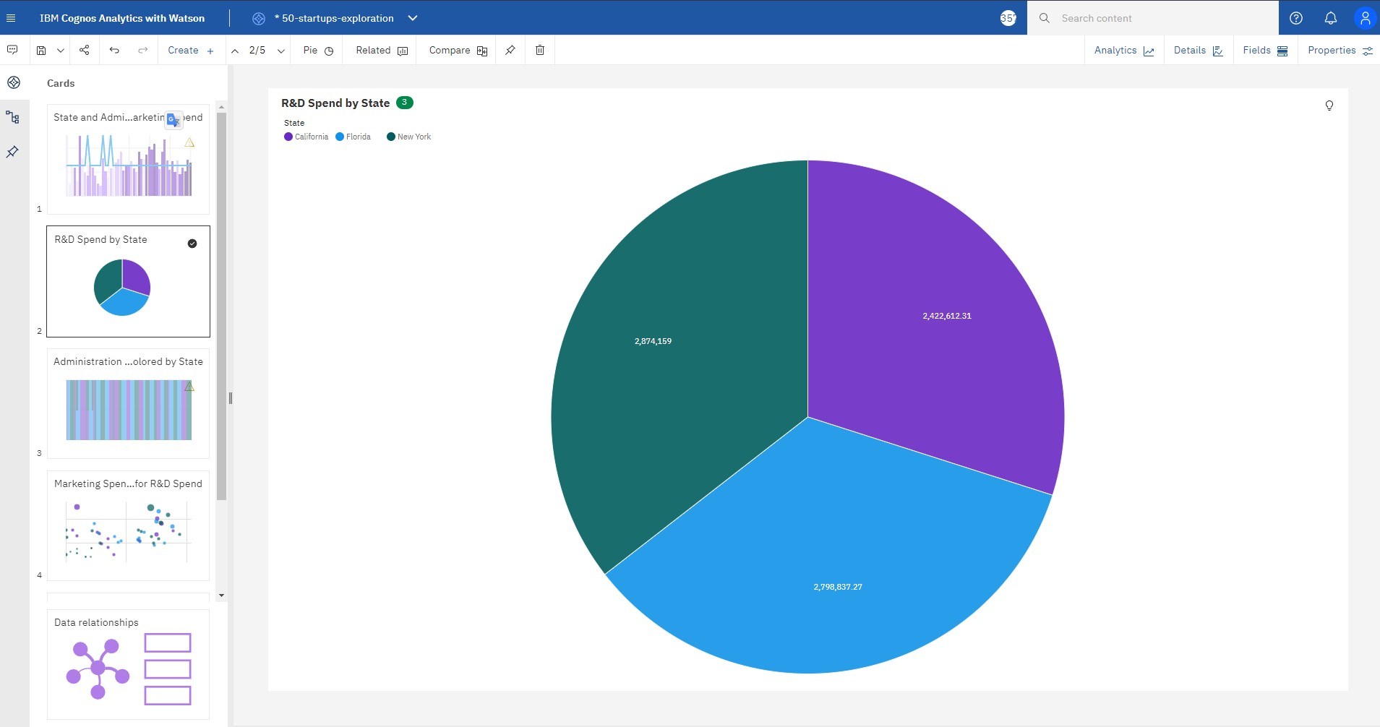

# Administration and Marketing Spend for R&D Spend colored by State

**Marketing Spend and Administration with State and State for R&D Spend**

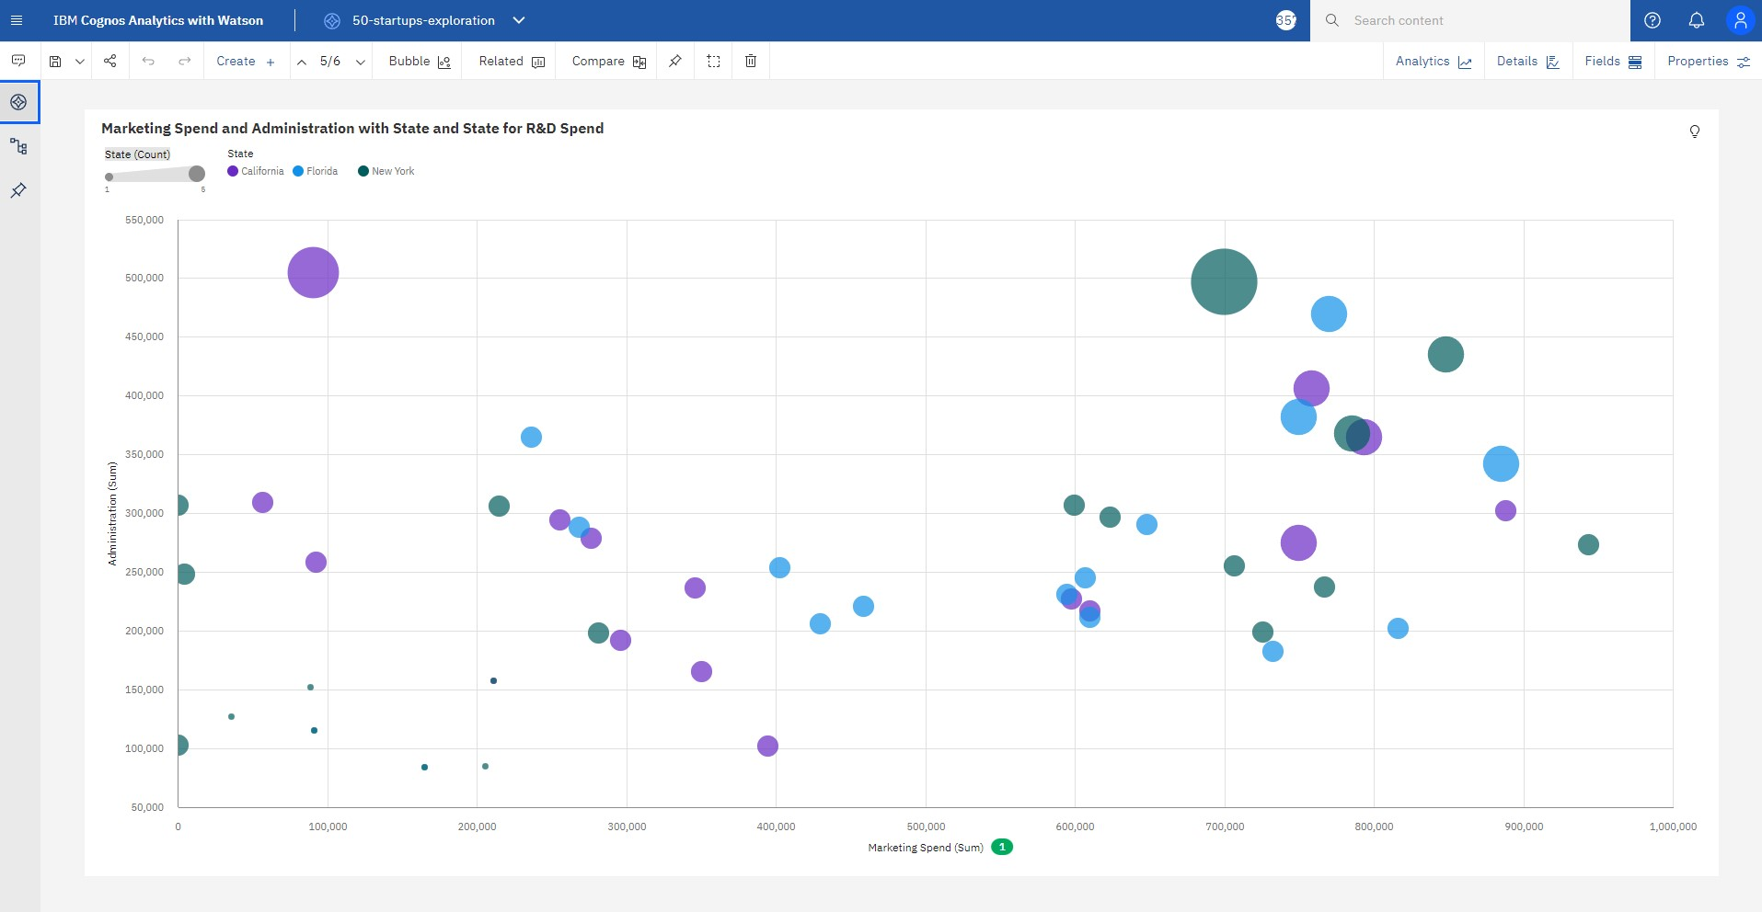

# Administration by R&D Spend colored by State

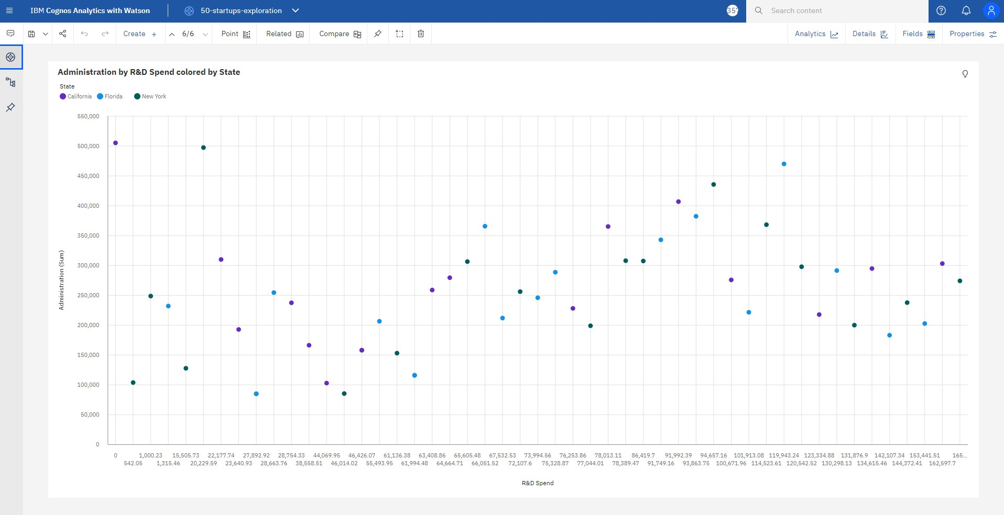

Explore data relationship

